附件1：
貢寮保育區
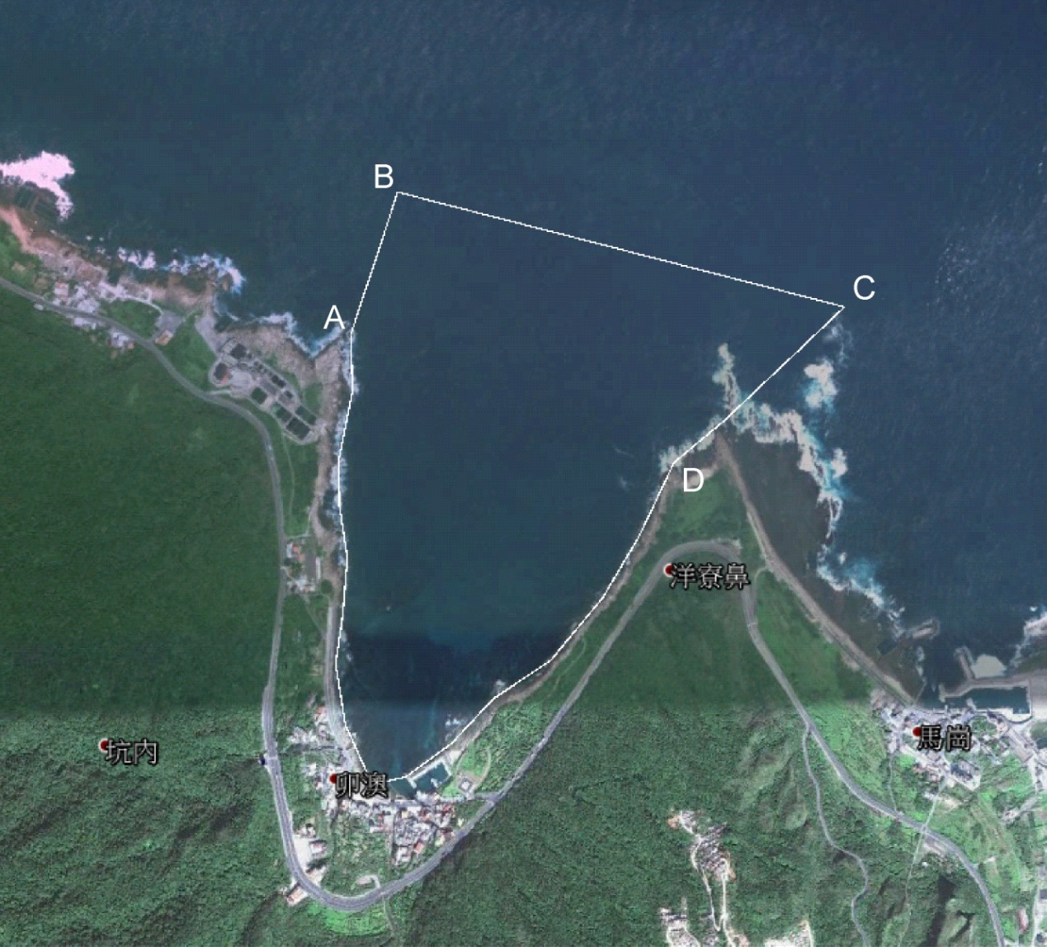
各點位 | 經緯度（WGS-84座標系統）
A | E 121°59'22.19",N 25°1'16.33"
B | E 121°59'26.59",N 25°1'25.62"
C | E 122°0'0.67",N 25°1'17.65"
D | E 121°59'51.15",N 25°1'9.55"

附件2：
萬里保育區
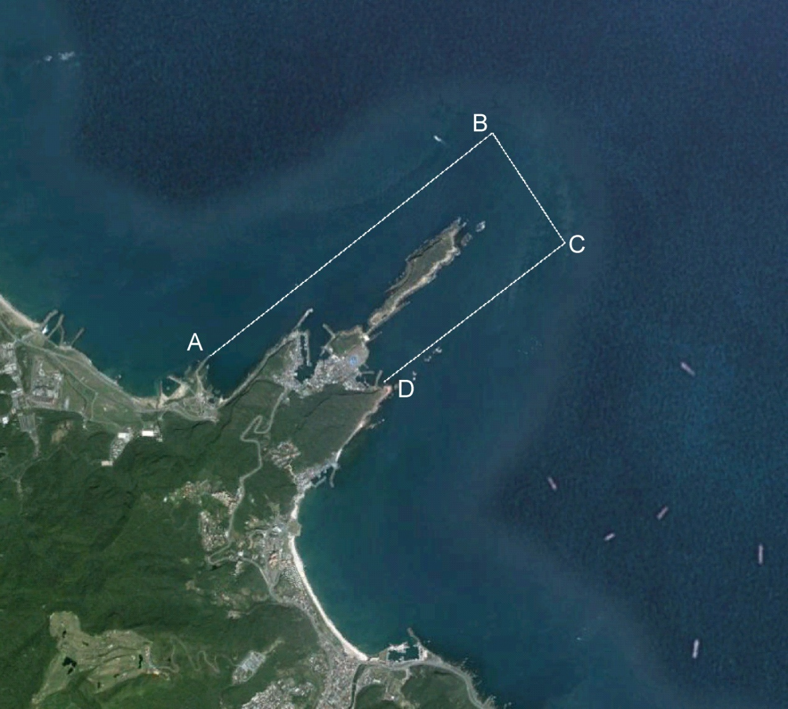
E
F
各點位 | 經緯度（WGS-84座標系統）
A | E 121°40'40.87",N 25°12'20.41"
B | E 121°42'15.79",N 25°13'28.28"
C | E 121°42'40.15",N 25°12'54.76"
D | E 121°41'39.27",N 25°12'12.53"
E | E 121°41'35.4" ,N 25°12'15.6"
F | E 121°41'38.6" ,N 25°12'27.8"

附件3：
瑞芳保育區
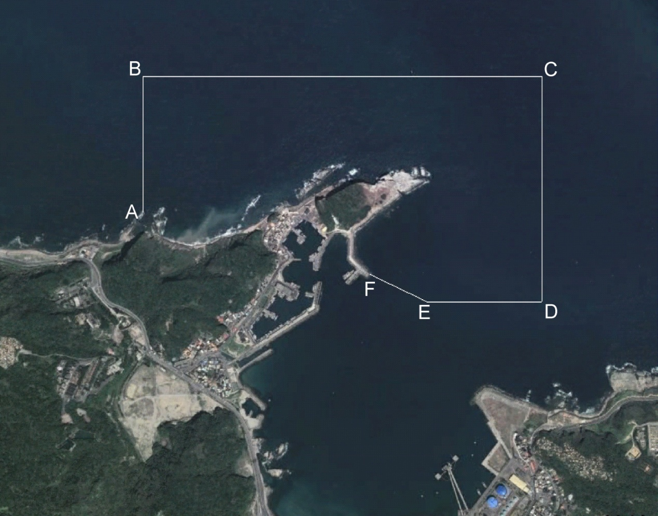
各點位 | 經緯度（WGS-84座標系統）
A點 | E121°48'51.502",N 25°8'3.776"
B點 | E121°48'51.502",N 25°8'22.678"
C點 | E121°49'52.744",N 25°8'22.678"
D點 | E121°49'52.744",N 25°7'51.35"
E點 | E121°49'35.137",N 25°7'51.35"
F點 | E121°49'26.307",N 25°7'55.172"

